**Class Exercise: Search for files of your interest.**

Execute the following tasks, capture and paste your results onto this document accordingly.

1. Write the command to locate all the files at /usr?

*You may want to explore helps on the grep command: man grep*

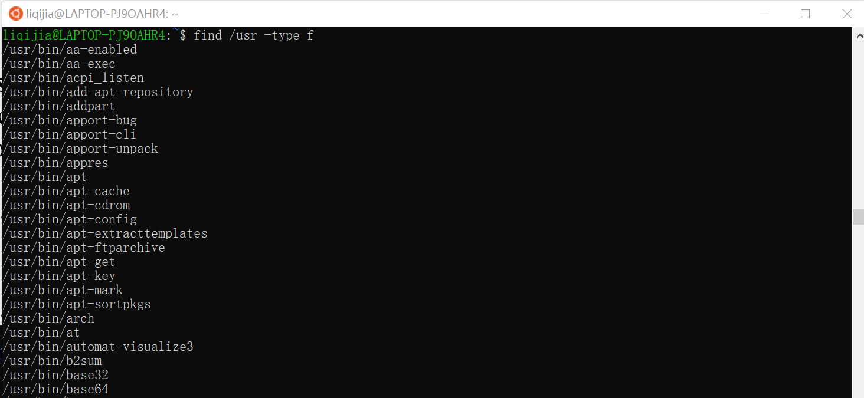

1. Write the command to locate all the file+path in /usr that contains “lib”?

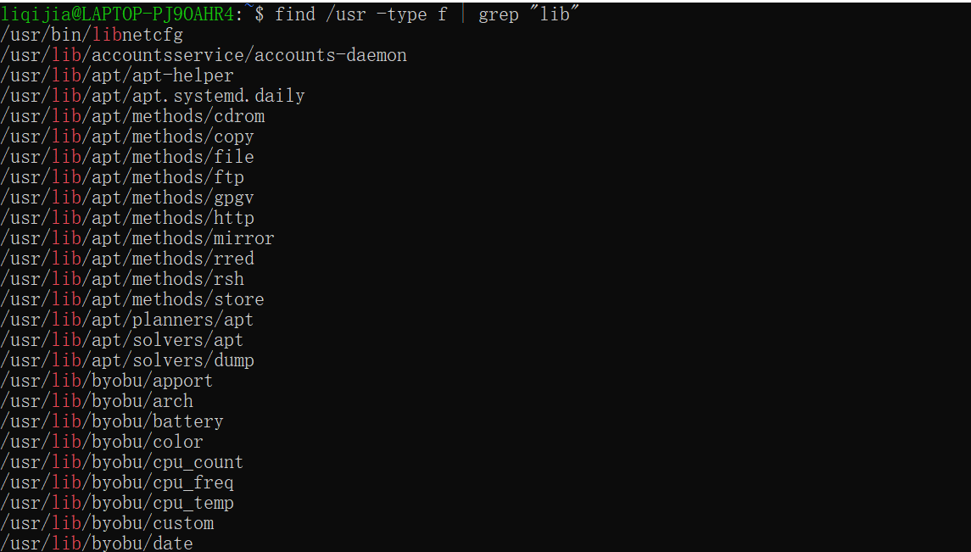

1. Write the command to locate all the file+path in /usr that contains “lib” and “so”?

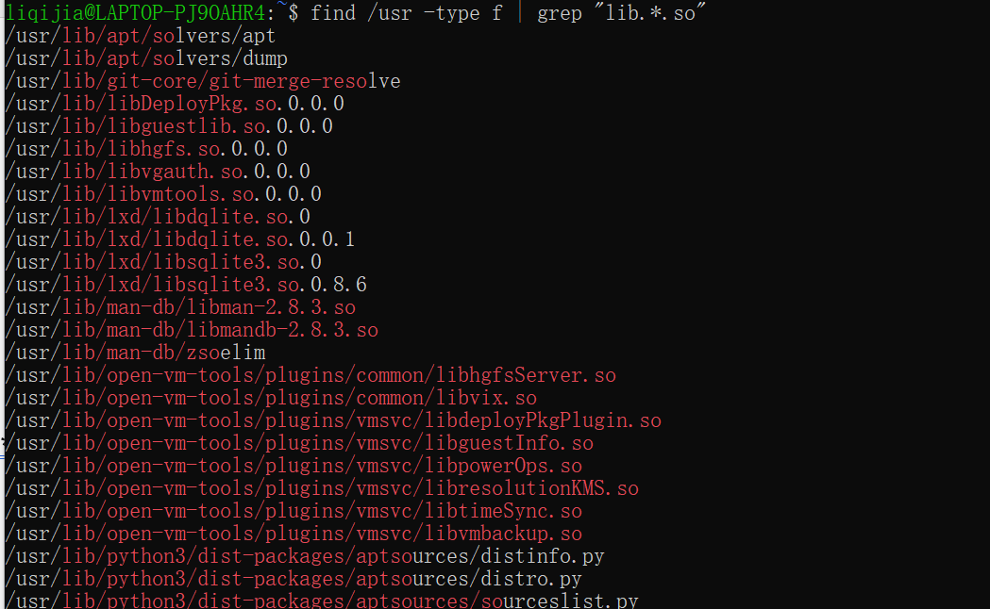

1. Write the command to locate all the file in /usr that contains “/lib” and “so”?

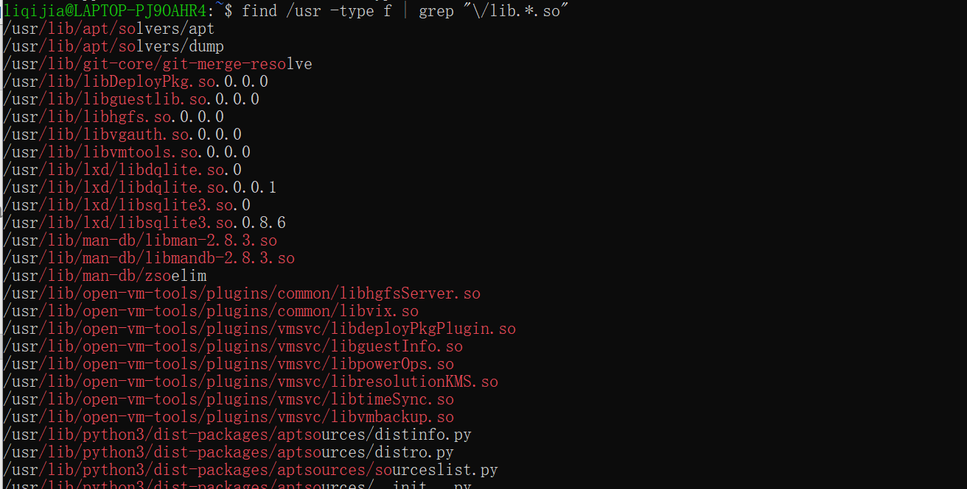

1. Execute the “history” command and capture the screenshot of its output.

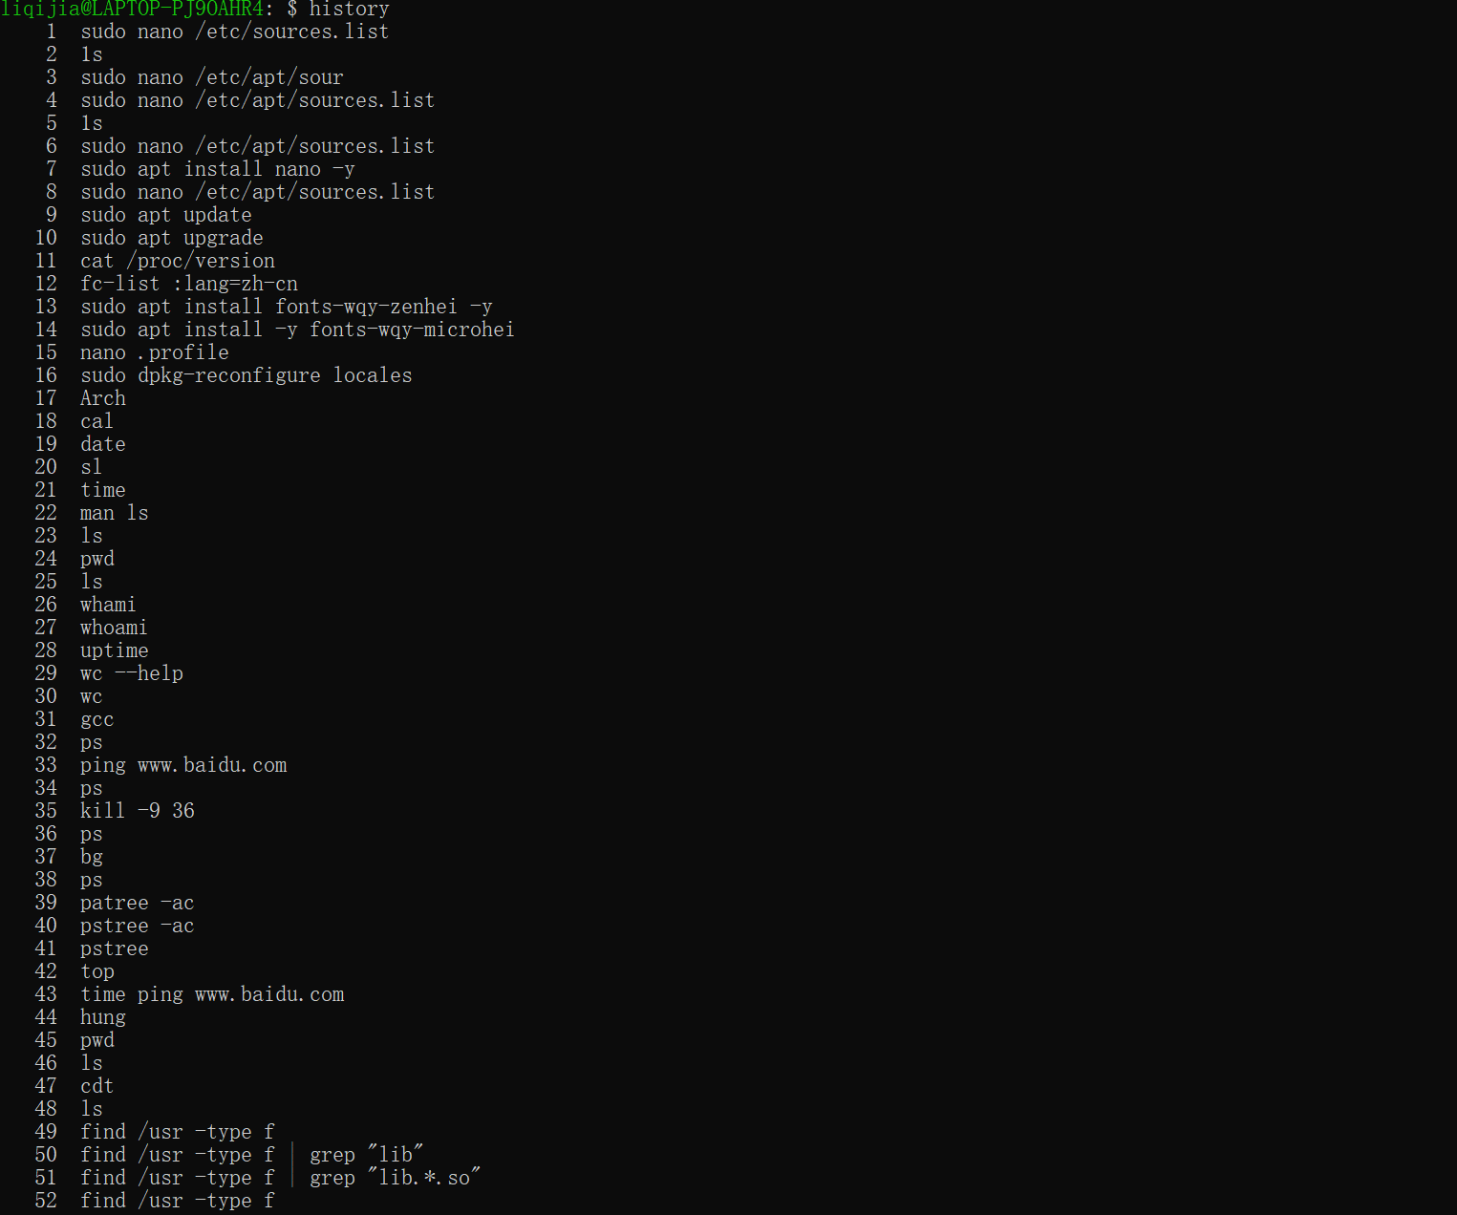

1. Go to your PC Desktop directory, and locate all the files that are
2. File name contains “cs240” (case insensitive).



1. [file type = .docx].

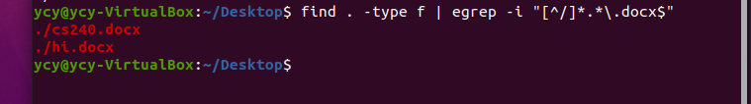

1. Explore and reflect, if/how step 6 can be done in the Window OS/Mac OS environment?
2. Open my computer and search for file suffixes
3. Write relevant scripts in the editor，like Visual Studio , Visual Studio Code.

**Note, example command sequence is shown below:**

find /usr -type f

find /usr -type f | grep "lib"

find /usr -type f | grep "lib.*.so"

find /usr -type f | grep "\/lib.*.so"

find /usr -type f | grep "\/lib.*.so$"

history

cd /mnt/c/Users/john_/Desktop

find . -type f | egrep -i "[^/]*cs240.*\.docx$"

**Submission:**

Please submit online. If that fails, email your results to: [bangpanliang@gmail.com](mailto:jcc4018@qq.com)

The subject of your email should be: [StudentID, Assignment Name]